11/22/2024

XBCGD7312

Summative Document

Pasqaulo Shields, Sybrandt van Niekerk, Malcom Joe Thonger, Nasser el Quoar, Maxime Declerck, Eugene van den Berg

Alex Carvalho

Table of Contents

List of Figures: 3

Github Link 3

Itch.io Link 3

List of Group members & Their Responsibilities: 4

The title of the game 4

An explanation of the serious issue in disadvantaged communities that is addressed by the game 5

Overview: 5

Identified Problem: 5

Why this problem is relevant and appropriate to the selected target group 5

Addressing Unemployment 5

Target audience 6

Educational Approach 6

Practical skills: 6

How it addresses the issue: 6

Interactive learning 6

Real-world application 6

Empowerment 7

The genre of the game 7

The age group that the game was developed for 7

Pictures and explanations of all assets and characters in the game 8

UI Assets 8

Main Menu 8

Make Your Own CV: 9

Bottom panel 10

CV Review 11

Employee Manager Menu: 12

Game Assets 13

Character Models: 13

Character Animations 18

Environment: 21

Game rules, game specs and instructions for players 24

Game Rules: 24

Game Specs: 24

Instructions for Players 24

The Play Test Report – Play tester Feedback 25

Play Tester 1: 25

Environment 25

Game Mechanics 25

Gameplay 26

Game Purpose 26

Play Tester 2: 26

Playtester 3: 29

Environment 29

Game Mechanics 29

Gameplay 29

Game Purpose 30

Bugs & Issues: 30

Minimum system requirements 32

Explanation and description of the objective of the game, the characters, the assets, the game world, the interface design, the story/narrative, and Game progression 33

Objectives 33

Core Game Mechanics: 34

Characters: 35

Explanation 35

Game World: 36

Explanation 36

Interface Design: 37

Explanation 38

Story & Narrative 38

Game Narrative 38

Explanation: 38

Game Progression 39

Explanation: 40

References: 41

# List of Figures:

Figure 1: Table showing the Group members and their roles and responsibilities (Shields, 2024) 4

Figure 2: Main Menu UI (Shields, 2024) 8

Figure 3: Make your own CV with Options (Thonger, 2024) 9

Figure 4: Make your own CV UI (Thonger, 2024) 9

Figure 5: Bottom panel Navigation UI (Shields, 2024) 10

Figure 6: CV Review UI (Thonger, 2024) 11

Figure 7: Employee Manager UI (Shields, 2024) 12

Figure 8: Character Model 1 (Mixamo, 2024) 13

Figure 9: Character Model 2 (Mixamo, 2024) 13

Figure 10: Character Model 3 (Mixamo, 2024) 14

Figure 11: Character Model 4 (Mixamo, 2024) 14

Figure 12: Character Model 5 (Mixamo, 2024) 15

Figure 13: Character Model 6 (Mixamo, 2024) 15

Figure 14: Character Model 7 (Mixamo, 2024) 16

Figure 15: Character Model 8 (Mixamo, 2024) 16

Figure 16: Character Sitting Animation (Mixamo, 2024) 18

Figure 17: Character Talking Animation (Mixamo, 2024) 18

Figure 18: Character Walking Animation 1 (Mixamo, 2024) 19

Figure 19: Character Walking Animation 2 (Mixamo, 2024) 19

Figure 20: Character Talking on Phone Animation (Mixamo, 2024) 20

Figure 21: Initial Office Environment (el Quoar, 2024) 21

Figure 22: New Office Floor (el Quoar, 2024) 21

Figure 23: New office floor with highrise (el Quoar, 2024) 22

Figure 24: Full game environment (el Quoar) 22

Figure 25: Final Evaluation of Kimmy Bonthys playthrough (Thonger, 2024) 28

# Github Link

<https://github.com/Sywurm/WILL_POE>

# Itch.io Link

<https://unicornfishy.itch.io/cvio>

# List of Group members & Their Responsibilities:

|  |  |  |
| --- | --- | --- |
| **Name** | **Role** | **Responsibility** |
| Pasqaulo Shields | Artist and Supporting Developer/UI Designer | Project Manager  Designing UI Assets and integrating the UI functionality  Designing Art Assets that can be implemented in the game  Documentation |
| Maxime Declerck | Developer & Supporting Game Designer | Programming the game mechanics that works with the game levels  Programming the level/ day system  Bug Fixing |
| Malcom Joe Thonger | UI Designer & Supporting Sound Designer | Designing UI Assets and integrating the UI functionality  Create your own CV UI and functionality  Implementing the sound effects and music |
| Sybrandt van Niekerk | Sound Designer & Supporting Developer | Implementing the sound effects and music  Employee Manager that manages the hiring and firing of employees |
| Eugene van den Berg | Developer | Employee Manager that manages the hiring and firing of employees  Procedural CV Generation |
| Nasser el Quoar | Level Design & Supporting Artist | Designing the office floor and the environment  Integrating the animations of the office employees as well as their behaviour |

Figure : Table showing the Group members and their roles and responsibilities (Shields, 2024)

# The title of the game

CV.io

# An explanation of the serious issue in disadvantaged communities that is addressed by the game

## Overview:

Games 4 Change is developing a game aimed at educating high school students and adults on how to craft an effective and well-written CV. We recognize the importance of understanding CV writing, as a well-structured CV can significantly improve a person’s chance of being hired (Indeed, 2023). The game aims to address unemployment.

Through our research, we identified that a major contributor to unemployment is a lack of education and knowledge about job application skills. By playing this game, we hope to equip our audience with the skills needed to create a compelling CV for job applications.

In the game, players take on the role of a hiring manager tasked with reviewing CVs. They will learn to distinguish between strong and weak CVs and make hiring decisions based on their evaluations. This interactive experience aims to teach valuable CV-writing skills that can support players in their career journeys.

## Identified Problem:

The problem that we have identified that is currently very active in South Africa is unemployment. According to Sprake (2024), South Africa faces a significant unemployment problem. This continues to pose challenges for the country as the county’s social and economic development is being negatively impacted by the unemployment rate. There is a complex range of factors contributing to this issue such as: lack of skills, limited access to quality education and training, and inadequate job creation. Although we don’t have the resources to create jobs, we have the knowledge and skills to help educate and train people by providing them with the necessary resources to create better opportunities to find employment.

## Why this problem is relevant and appropriate to the selected target group

### Addressing Unemployment

Unemployment is a significant issue in South Africa, particularly among young adults and high school graduates. Providing education on writing effective CVs directly addresses the problem by empowering individuals with the necessary skills to increase their employability. According to Naidoo P (2021), South Africa is facing a significant unemployment crisis, with various causes, effects, and potential solutions

### Target audience

Youth unemployment in South Africa is a pressing issue, as highlighted in a publication by Rogan (2019). Focusing on individuals aged 15 and above is appropriate because it captures both high school students preparing for their future careers and adults who may be seeking employment or looking to improve their job prospects. By targeting the youth, the game can have a broad impact on reducing unemployment rates.

### Educational Approach

By using a game format for education, we can create an innovative and engaging experience for young people. Many young people are familiar with and enjoy playing games, making this an effective system for delivering educational content on CV writing. UNICEF South Africa (2012) emphasizes the role of education in addressing unemployment and its importance in providing solutions to this issue.

### Practical skills:

CV writing is a practical skill that is universally applicable. Regardless of one's educational background or career aspirations, knowing how to craft a CV is essential for securing employment opportunities.

## How it addresses the issue:

### Interactive learning

By simulating the role of a hiring manager, players actively engage in the decision-making process of assessing CVs. This hands-on approach allows them to understand the key components of a well-written CV and the importance of presentation and relevant information. Using games for educational purposes has been studied extensively, with research indicating both benefits and challenges according to Kafai and Burke (2016).

**Feedback Mechanism:** The game would provide feedback to players on their CV evaluations.

This feedback mechanism is necessary for teaching and helping players understand the reasoning behind hiring decisions.

### Real-world application

CV.io bridges the gap between theory and practice by simulating real-world scenarios. As players navigate through various CVs, they gain practical insights into what employers look for and how to tailor their own CVs to meet industry standards.

### Empowerment

By equipping individuals with the skills to create effective CVs, CV.io empowers them to take control of their job search process. This sense of agency brings forth confidence and motivation, leading to better outcomes in the job market.

# The genre of the game

**Theme:** Employment

**Genre:** Role-Playing

The game revolves around the theme of employment. The genre of the game will be Role-Playing as the player takes on the role of a hiring manager that needs to fill a specific quota of new hires.

# The age group that the game was developed for

As mentioned previously, the target audience that the game will be catered for is young adults between ages of 18 – 35 who are currently looking for work.

As mentioned previously, youth unemployment in South Africa is a pressing issue, as highlighted in a publication by Rogan (2019). Focusing on individuals aged 15 and above is appropriate because it captures both high school students preparing for their future careers and adults who may be seeking employment or looking to improve their job prospects. By targeting the youth, the game can have a broad impact on reducing unemployment rates.

# Pictures and explanations of all assets and characters in the game

## UI Assets

### Main Menu

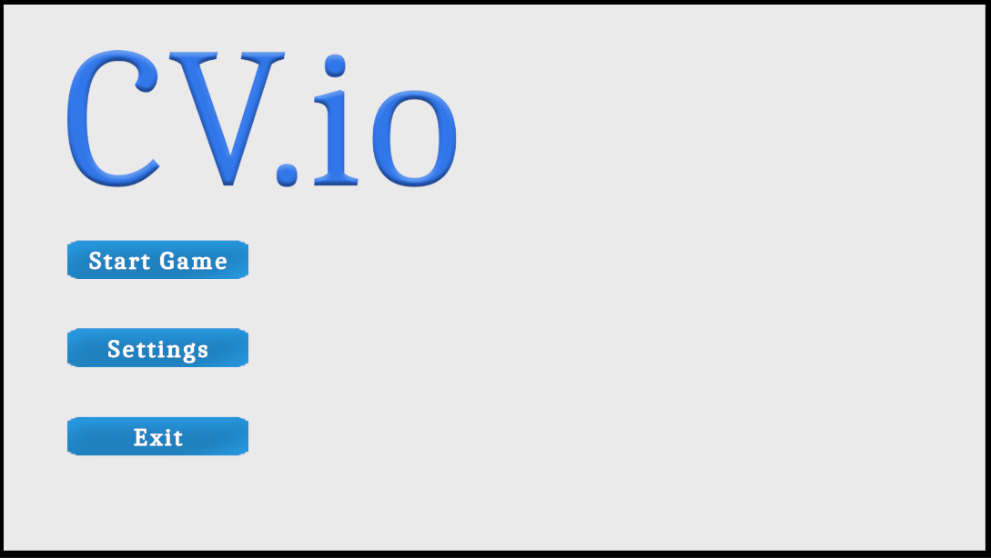

Figure : Main Menu UI (Shields, 2024)

#### Explanation:

The main menu is the first page the user sees, and thus will carry a lot of the design language and expectations of the games UI form here on. That’s why the UI features modern design choices, such as rounded corners on buttons, and an animation which in turn, piques the user’s interest (Mukherjee, 2023). This page also demonstrates the colour palette to the user. The palette features whites, blues and black, which is done to create a cohesive and well-designed interface for the user (Microsoft Create Team, 2023). Having colours will make the experience more pleasant as colours not only imply meaning but keeps the feeling of the game positive and pleasant (PPG, 2022).

The primary use of this UI is to allow for the player to either setup the game though settings, exit the game if their play session is complete, or start a game.

### Make Your Own CV:

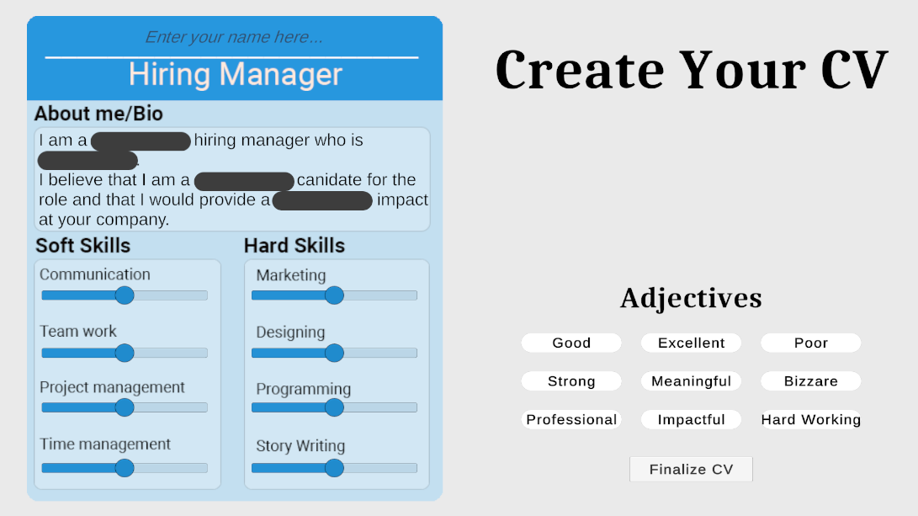

Figure : Make your own CV with Options (Thonger, 2024)

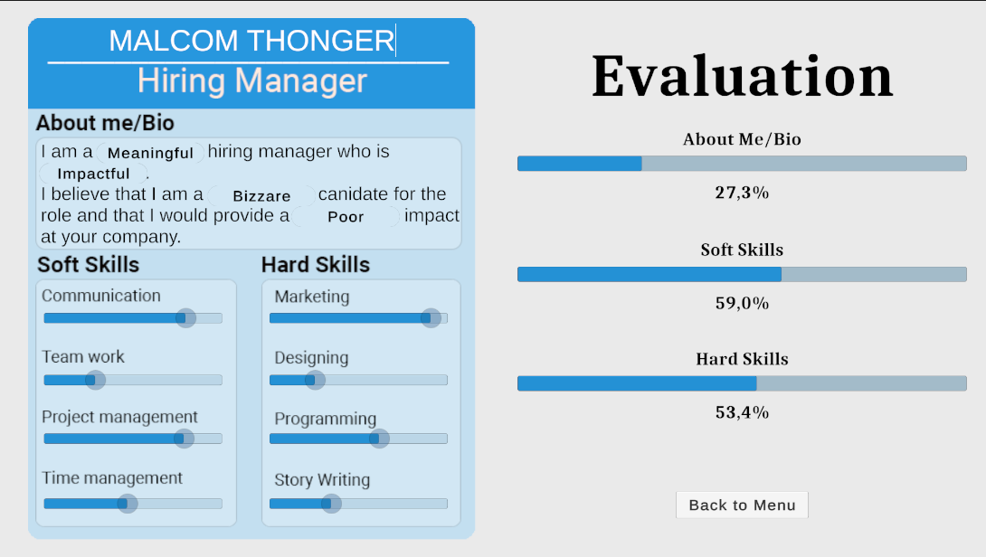

Figure : Make your own CV UI (Thonger, 2024)

#### Explanation:

The create your CV page uses many of the same design patterns seen throughout the project as it utilises the same colours and shapes to create a cohesive and visually interesting design. The use of this page is for the user to create a CV after they have finished the main section of the game with all the knowledge they have acquired from playing the game. The sliders on the CV are for the player to rate themselves on the given topics and rate how well they believe they perform at that skill.

The black blocks and the Adjectives on the right are both a part of the drag and drop feature where the player must select which adjectives they believe fits the CV the best and will be rated once they click finalize CV. This gives the player meaningful feedback about their knowledge of how to make a CV as by this point in the game they should have a better understanding of what a good CV looks like, this ultimately fulfils our games purpose to help educate people on making a CV.

### Bottom panel

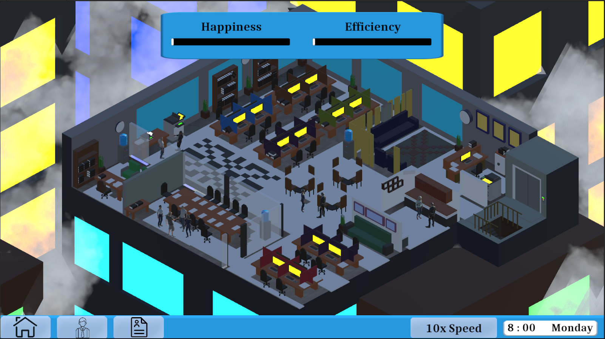

Figure : Bottom panel Navigation UI (Shields, 2024)

#### Explanation:

The bottom panel is the main UI component of the main game scene, and is designed after operating system’s taskbars, namely Windows 7 (Microsoft, 2022). The UI was designed this way to create familiarity and make it easier for the player to intuitively use the UI. As with the game being released on PC, most users will already be familiar with the Windows style of UI. The UI also features the before mentioned design choices and colours to keep with visual consistency.

The UI is used by clicking on one of the four icons. This will cause the relevant menu to be presented to the player. The buttons are as follows: Pause, Employees, and CVs. On the far-right hand side of the taskbar is the 10x speed button and the current time and date. These are grouped together since they both relate to time. The 10x button speeds up time by 10 times when held down, and the time of day is shown next to it, with 30 seconds or real time – with no speed up – being equivalent to 30 in-game minutes.

### CV Review

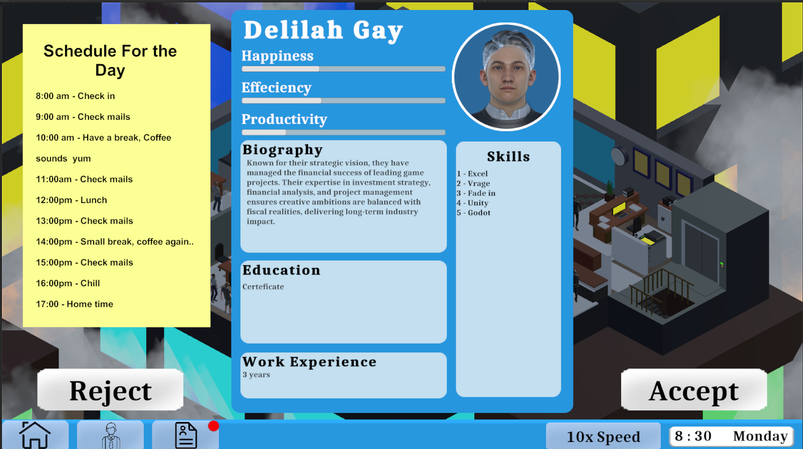

Figure : CV Review UI (Thonger, 2024)

#### Explanation:

The CV review panel is what the player uses to accept and reject CVs and through this they can hire employees. The **above** CV is an example of a CV in-game and will be populated with procedurally generated CV information. Also note that the icon for CV’s on the taskbar has a red notification on it, this is to alert the player that a CV has been generated, and is currently available for review. The ‘Schedule for the Day’ on the left is there for the player to get an idea of what they’re doing and for them to track and see how day along in the day they are. It is designed to look like a sticky-note, hence why its colour is not aligned with the colour scheme of the game. However, the different colour is important as breaking the colour scheme here is critical to drawing attention to the checklist, ensuring that the player doesn’t forget it’s there (Killam, 2009).

### Employee Manager Menu:

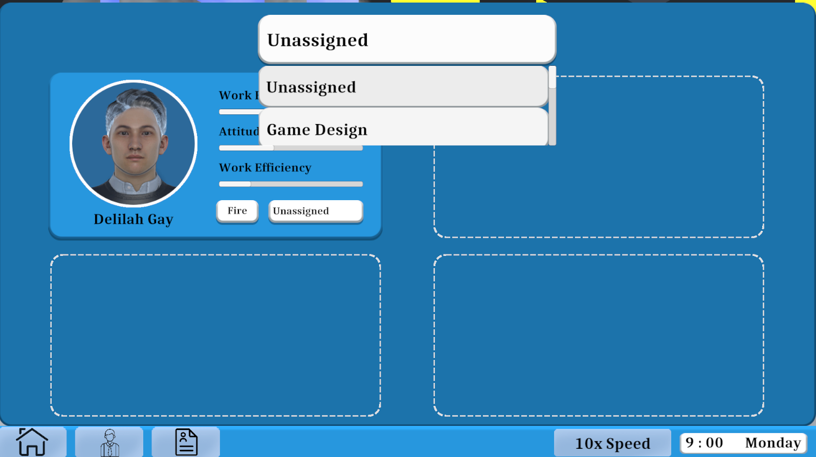

Figure : Employee Manager UI (Shields, 2024)

#### Explanation:

The employee manager menu is where the player can see who is working for the company currently, what department they’re working in currently (**above** is an example of a newly hired employee who is still unassigned), and how they are doing at their work. The player is also able to either fire them, or change which department they’re working in. Of note, we’ve included an icon of the employee with their name below, which functionally adds nothing, but is critical to humanising the experience and making the employees feel like actual employees (Aleksandra, 2016).

## Game Assets

### Character Models:

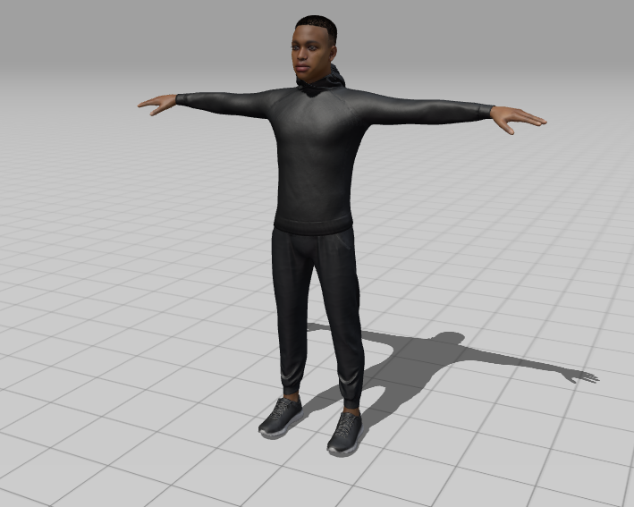

**Figure 8: Character Model 1 (Mixamo, 2024)**

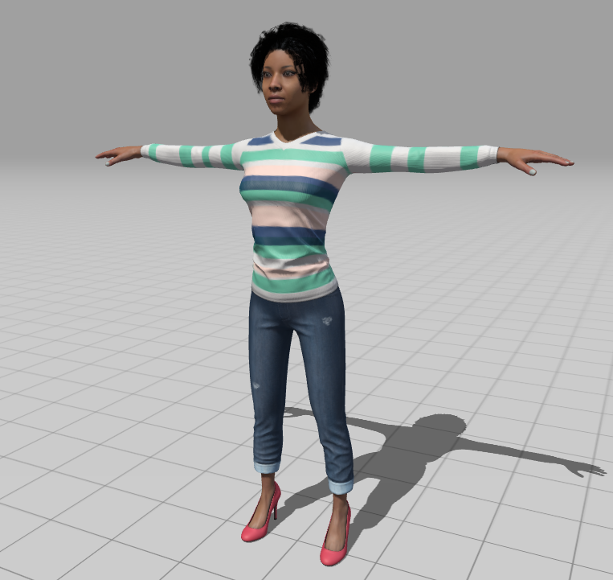

**Figure 9: Character Model 2 (Mixamo, 2024)**

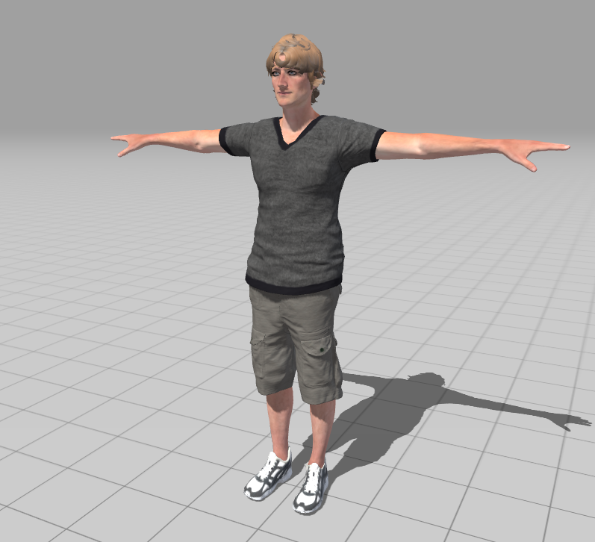

**Figure 10: Character Model 3 (Mixamo, 2024)**

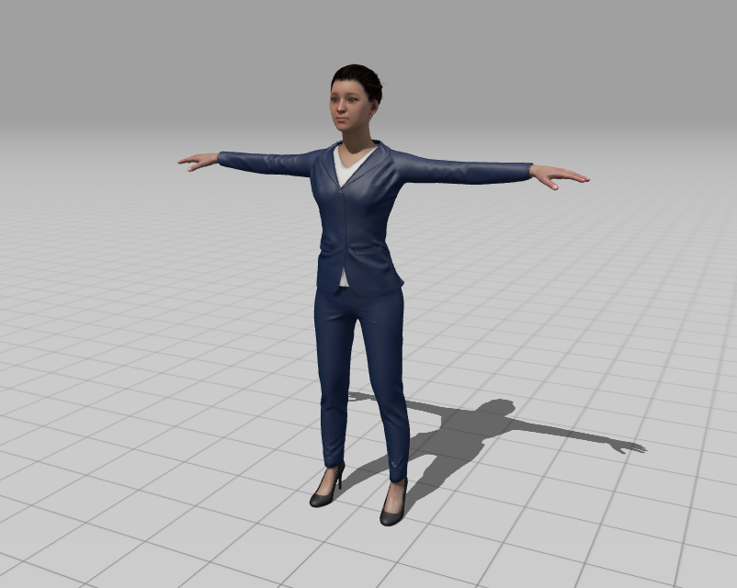

**Figure 11: Character Model 4 (Mixamo, 2024)**

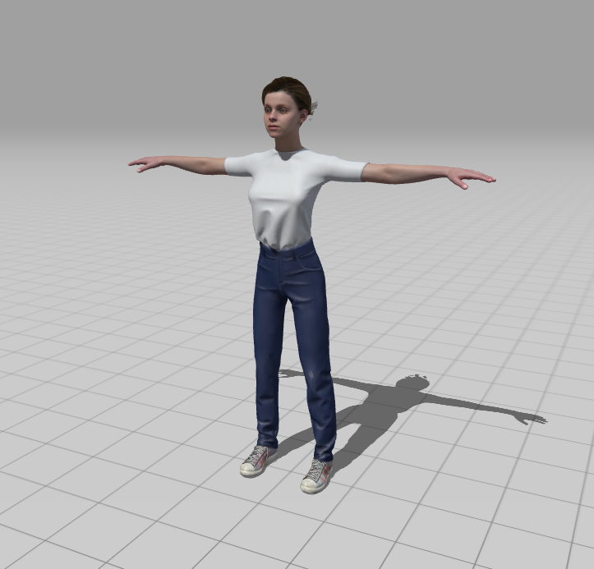

**Figure 12: Character Model 5 (Mixamo, 2024)**

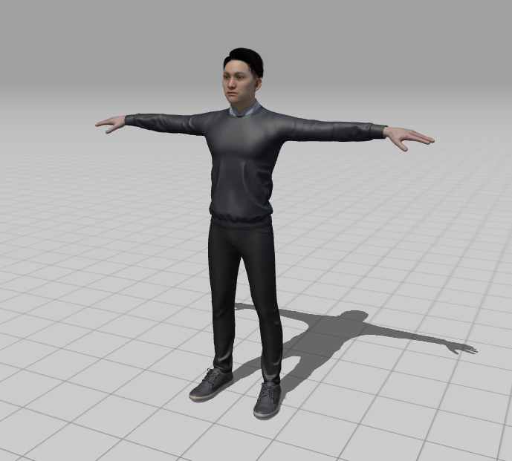

**Figure 13: Character Model 6 (Mixamo, 2024)**

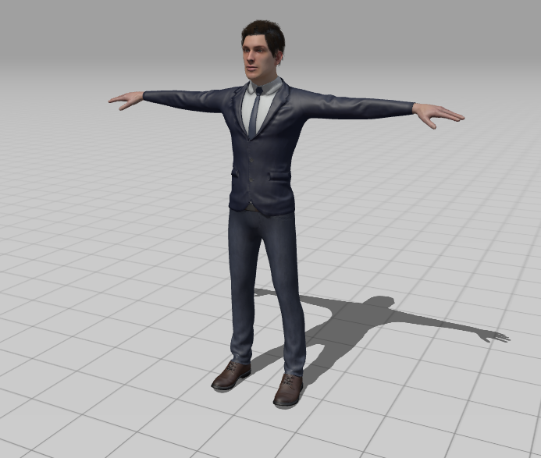

**Figure 14: Character Model 7 (Mixamo, 2024)**

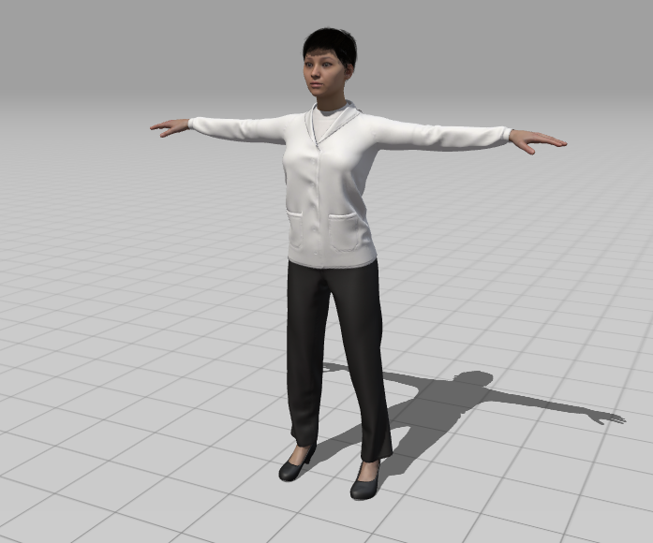

**Figure 15: Character Model 8 (Mixamo, 2024)**

#### Explanation:

The character models have carefully been chosen to showcase diversity in both looks and character roles. This helps players to connect with the game, evoking thoughts like, “Yes, I can imagine myself in such an office.” Every model is designed with certain features including the types of clothes, hairstyles and facial expressions. which are all referenced from real office settings. These characters include the player model, employees and job applicants that belong to different fields and professions.

Coursera (2024) emphasizes the importance of diversity in workplace environments, stating that representation fosters inclusivity and can inspire individuals to envision themselves in professional settings. Similarly, our game leverages diversity in its characters to resonate with a wide audience, increasing the educational value.

For example, the character's design reflects the modern professional, dressed in neutral tones to symbolize versatility, as seen in figure 11. The employees' models showcase specific traits that align with various job roles, such as a formal suit for a manager in figure 14 or casual wear for a tech specialist, as depicted in figure 13. Meanwhile, job applicants have subtle expressions and body language, offering insights into their personalities and suitability for different roles.

### Character Animations



**Figure 16: Character Sitting Animation (Mixamo, 2024)**



**Figure 17: Character Talking Animation (Mixamo, 2024)**



**Figure 18: Character Walking Animation 1 (Mixamo, 2024)**



**Figure 19: Character Walking Animation 2 (Mixamo, 2024)**



**Figure 20: Character Talking on Phone Animation (Mixamo, 2024)**

Explanation

These models are brought to life through animations that portray believable movements and emotions. For instance, characters move to look over documents and nods or shakes their head to indicate they are focusing on their work. Characters also have walk and talk animations as they move around in the scene.

According to Indeed (2024), body language refers to various nonverbal communication methods used to express intentions and emotions. It includes facial expressions, gestures, postures, and other physical signals, which can be deliberate or subconscious and often complement verbal communication. Understanding body language is crucial in many scenarios, as it can significantly influence interactions and convey messages that words might not fully express. (Indeed.2024).

The job applicant characters incorporate small movements such as, straightening their backs, twiddling their fingers, or standing at ease, which can help the players appreciate the role of one’s body language in the workspace or when in an interview. These enhances the players’ interest in the game and reinforce the educative aspect of the game through the realistic setting.

### Environment:

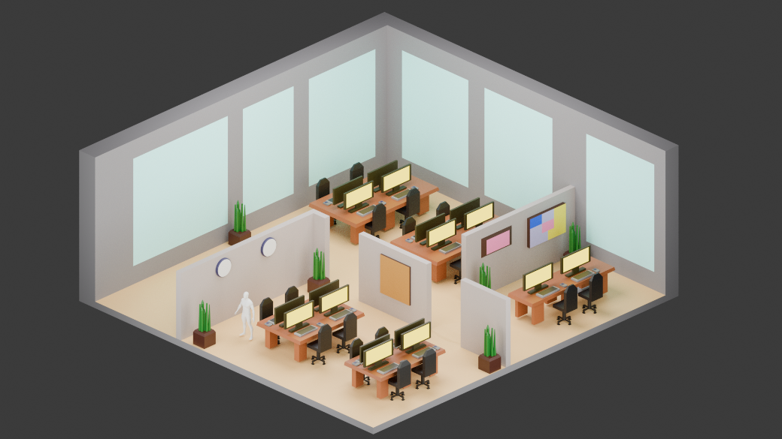

**Figure 21: Initial Office Environment (el Quoar, 2024)**

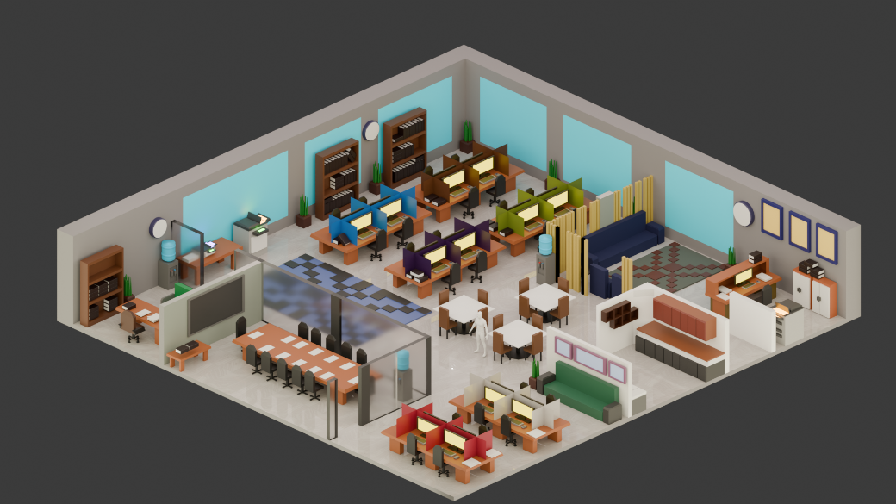

**Figure 22: New Office Floor (el Quoar, 2024)**

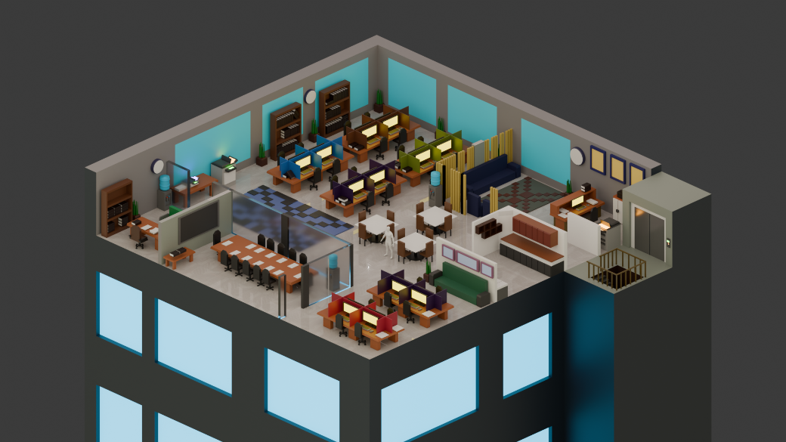

**Figure 23: New office floor with highrise (el Quoar, 2024)**

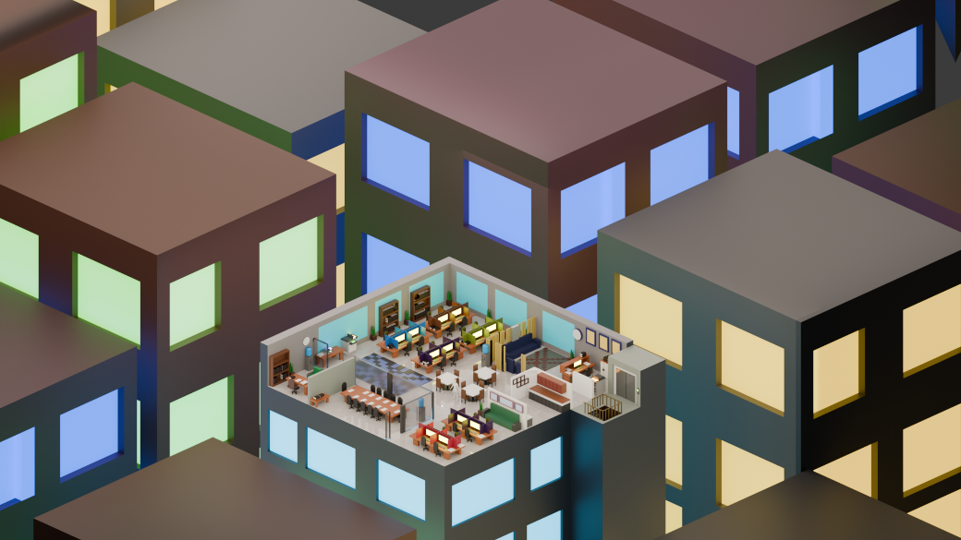

**Figure 24: Full game environment (el Quoar)**

Explanation

The main goal for the office layout is to engage the players in an environment that is true to how an average office in the city of Johannesburg would look like. The reason we made this decision is to try ground players in a realistic setting of where they might work. By mimicking the design of a Johannesburg office, players are introduced to a setting that feels authentic and familiar. They can in turn start grasping the idea of being in an office and not be unfamiliar with how an office works when entering the work force. They can then turn their attention to the main ideas of the game and still enjoy an all-rounded office experience.

The office uses a modern design to help players remain concentrated on the hiring and managing of the office staff while the game gradually familiarizes them with office layouts. Modern office designs usually include neat and clean layouts, systematic workstations, and minimal distractions which fit well with the premise of the game that teaches recruitment skills. This way, players can concentrate on their tasks without being distracted with over-objectified or cluttered layouts in the game.

Looking at the design in figure 20, we made a few tables to serve as office space for the employees that the player will hire during the game and manage the employees in the office. I wanted to make the design look as simple as possible and not look cluttered, so it doesn’t look too complicated for the player. I based the colour scheme off some real-life references of offices and insured the colours didn’t look out of place or clashed with each other in terms of design principles. According to wbWood (2023), lighter colours such as greys, neutrals, and greens not only enhance the natural feel of a workspace but also influence productivity through colour psychology. For instance, grey tones convey sophistication and simplicity, green tones evoke calmness and comfort, and orange accents can stimulate creativity in collaborative areas. As we developed the game more, we discussed making the game more detailed for the player experience. We wanted to add different departments for the employees that players would be designated to. Thus, the first design we made would need to be changed, looking at figure 20. We went back to the drawing board and came up with a new design in figure 21.

We later placed the office on top of a building and added an elevator to make it look more like an office building in figure 21. To simulate the feeling of working in an office, the game scene has been designed to have a realistic office environment. A person’s thoughts are impacted by our surroundings, and empty spaces help us think more clearly. Every visitor and employee who steps foot inside a workplace will notice the disarray if it is overflowing with supplies. (Sunon.2022).

We designed and placed furniture such as desks to represent each department, career tools such as computers, filing cabinets, and other office essentials into the scene. To better distinguish between the different departments, we made each table have a different colour to represent different departments. Using distinct colours can also support players in quickly identifying which department an employee belongs to, streamlining decision-making and gameplay. This approach is supported by color psychology research, which highlights how colours can help differentiate spaces and encourage specific types of behaviour (Killam 2009). We also later added more buildings in the background to immerse players further, so that players feel like they are in the middle of the business district of Johannesburg, as seen in figure 23.

# Game rules, game specs and instructions for players

### Game Rules:

* Players can review a certain number of CVs a day. (This number will increase every day)
* CVs will be generated at intervals
* The player will only be able to hire as many employees as there are available spaces.
* If the player wants to hire an employee when all positions are filled, they will need to fire another employee.
* A workday starts at 8 and will end at 5. The player will only be able to complete actions during that time.
* The player is able to fire as many employees as they want, however, this will impact work productivity and efficiency.
* The player can fire a new hire within the same day.
* If any of the 2 bars (Employee Happiness, productivity), drop to 0, the player will fail the game as they made poor decisions.

### Game Specs:

**Memory:** 8 GB

**Graphics Card:** AMD Radeon HD 8350

**CPU:** Intel Core i7-610

**File Size:** 250mb

**OS:** Windows 10

### Instructions for Players

#### How to play:

##### CV Component:

The player will be able to accept and reject CVs inside of the CV menu. This menu will display the various aspects of a person’s CV, and the player will be able to click a button to accept or reject that new hire.

The player will need to fill specific jobs and see if the CV is applicable for that job.

##### Employee Manager Component:

The player will be able to view and manage employee positions by using the employee manager component.

The player will be able to see what departments need to be filled in this menu by selecting the department dropdown.

The player can select employees and fire that employee if they want to.

The player can also manage what department the employee belongs to, by selecting the department dropdown and moving them.

##### Office View Component:

The player is able to view the overall office using the office component.

This will display the various components such as overall employee productivity and happiness.

This component will also show the overall state of the office and how the employees will interact with eachother.

If any of the 2 bars (Employee Happiness, productivity), drop to 0, the player will fail the game as they made poor decisions.

# The Play Test Report – Play tester Feedback

Q Stands for Question, this is the question that was asked to the game tester.

A Stands for Answer, this is the answer that was given to the correlating Question.

## Play Tester 1:

### Environment

**Q: What do you think about the game world?  
A:** I think that the game world correctly portrays the type of game you are trying to make, I also think that it looks really good.

**Q: What could we do to improve the game world further?**  
**A:** I think that the game world is a bit boring and static at the moment, maybe adding some moving parts like clouds or just some non-player interactable characters jus to give the game some more life.

**Q:** **Do you find the lighting and camera positioning in the game world to suit the gameplay?**  
**A:** The lighting and camera positioning, helped to show me where to focus on the screen.

### Game Mechanics

**Q:** **One of the main mechanics behind the game is to accept and reject applications to join your company in the game. Do you think this mechanic was implemented well?**  
**A:** I think that the mechanic was implemented well and did its job but, I think that with more time you could have added more small quality if life features, like making the button grow as you hover over it. Just to add some more life to the game.

**Q:** **The second main mechanic behind the game is Manging employees, what did you think of this mechanic?**  
**A:** This mechanic was implemented well, as well. The only thing I think could be improved here is making it feel less static, with maybe a moving icon or something.

**Q:** **The third and final major mechanic the player encounters is the building your own CV mechanic, how did you feel about that?**  
**A:** I felt like it helped me to understand the point of the game, I had spent the whole game looking at CV’s but wasn’t entirely sure why. After going past that, I understood that I was actually teaching myself how to tell what a good CV could look like to, improve on mine.

### Gameplay

**Q: How Intuitive or clear are the game controls and mechanics for a new player?**  
**A:** I felt that most of the controls and UI was very easy and simple to understand. I think the only part where it was a bit confusing was with the tutorial where at one point there are 3 buttons but 2 of the buttons can not be pressed.

**Q:** **Did you experience frustration with the pacing or difficulty of the game?**  
**A**: At first, I thought that the pacing of the game was really slow because I only had 2 CV’s to look at. After figuring out that I could speed up time, it became much less of a problem for me.

**Q: Were there any gameplay features, mechanics or interactions that you found engaging and innovative?   
A:** The most innovative mechanic was by far the drag and drop build your own cv mechanic. I thought that that was really cool and that it really drove home the message of the game. I found that the majority of the game was engaging and seeing people walk around the office was cool.

### Game Purpose

**Q: What do you think the purpose of the game was?**  
**A:** I wasn’t entirely sure what the purpose of the game was until I got to the last section of the game. So for a while I thought it was just a fun simulation where you simulate being a hiring manager in an office. After getting to the build your own Cv, I understand that the purpose of the game was to learn what a good CV looks like.

**Q: Do you think that the game fulfilled its purpose?**  
**A:** I think that it did because once you have finished the whole game, It really comes together and fulfilled the purpose it wants to full. I think that some of the elements on their own don’t entirely do that but I think that’s fine.

## Play Tester 2:

**First playthrough observations**

* Enjoyed music
* Liked theme and design
* Noted settings bug.
* “Environment is quite dark”
* Noted it would be better if the notification for CV’s had a number in the red circle.
* Said “the CV UI thing is a bit messy, the formatting seems clunky”
* Got confused in the Employees tab, didn’t realise how to assign employees, didn’t realise how to look at different departments, said that he didn’t realise the drop downs were drop down menus.
* Got the same Face twice in a row and said, “oh wow that funny, I’ve got the same guy again, is that meant to happen?”
* Comments on the fact that employee’s menu doesn’t automatically open the Unassigned page.
* Liked the speed up feature.
* Didn’t see why rejecting would ever be necessary
* Got the same face for the 3rd time in a row, then got a different face.
* Was confused there is no alert that a day has passed. Said: “I feel like something should happen when the day changes, like nothing happened when the day changed”
* “My meters for Happiness and efficiency aren’t going down, shouldn’t they?”
* Noted that the Wednesday text doesn’t fit on screen and gets clipped.
* Liked that too many employees cannot be assigned to a section. “Oh, it doesn’t let you, I see, so you can’t add employees to a section if its full already? That makes sense.”
* Said scroll menu for categories was way too slow
* Commented on the feature that you can switch between tabs. “That’s nice, that you can click between the menus like that”
* Commented again about firing and rejecting again. “Why would I want to fire someone or reject someone, I don’t see a downside to just hiring everyone”
* Was annoyed that the CV menu closes when multiple CV’s are available
* Commented on some of the weird NPC animations. “why is there a guy inside of the couch? That’s hilarious”
* Felt unclear when the game ends.
* Got a game crash, too many employees got assigned to the game art tab, and when he opened it to check why he could keep assigning employees, the whole game crashed.
* Played again until the end, started taking notes again once he got to the Thank you for playing screen.
* Liked the Thank you for playing screen. “Oh cool I won, nice”
* Got confused on the CV maker, had to explain what to do, didn’t realise sliders were interactable.
* Found the grading redundant. “why show me the percentage for my skills If it’s just like an average or whatever, why not rather let me select 4 skills that I’m good at? Instead of these set ones that I’m not”

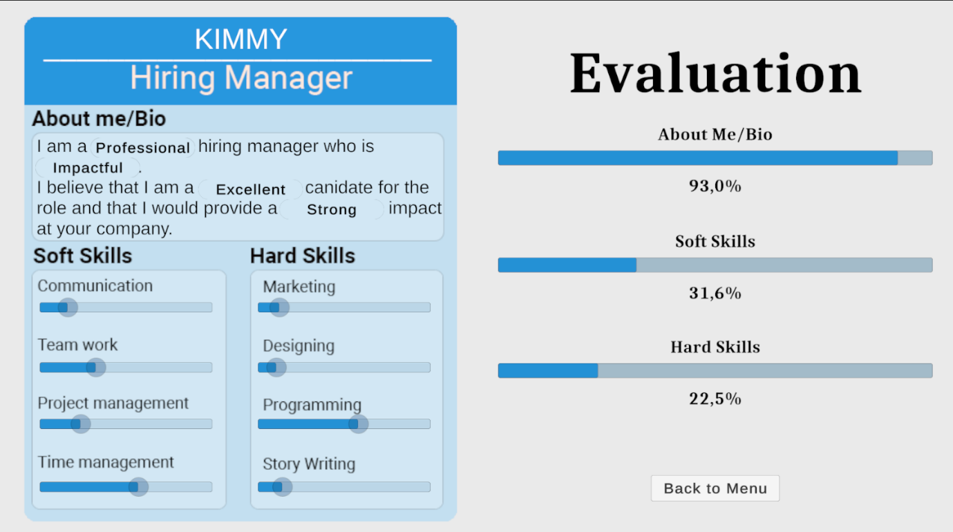

Figure : Final Evaluation of Kimmy Bonthys playthrough (Thonger, 2024)

**Post playthrough questions**

**Q: So, what did you think of the game?**  
**A:** It’s cool, I get what the whole thing is about, I just think its not very engaging, its just too slow paced.

**Q: What did you like about the game?**  
**A:** The Design of it was cool, I liked the little people moving around the office, they looked very broken, but I liked that, it was funny to watch, it made it feel less boring.

**Q: Were there any features you didn’t like**   
**A:** Nothing was like really bad, but I thought the game overall was very clunky and odd, it felt unintuitive and weird. It was easy to look past since it was slow paced, so I never felt rushed to do stuff, but also I felt like I didn’t know why to do anything. Hiring and firing employees seemed to have no effect? There was no score at the end, so how do I know how I did? Did I do well? Did I even play properly? Im not really sure.

**Q: Do you have any ideas of things you’d change?**  
**A:** Maybe make the employees section thing instead of a drop down for the different departments, make it like buttons or something for each category, I think if you can see all the categories and only one is selected, it will make more sense that you can select different ones.

**Q:** **How did you feel about the Ending of the game, the Create your CV section? Do you feel like it helped you or gave you an idea about creating your own CV?**  
**A:** Yes and no, I feel like its cool to see a CV, and it gives me an idea for how to visually design or make my CV, but it didn’t teach me, I feel like it was confusing and that I didn’t understand why I got the results I did (in the evaluation). I also feel like it didn’t explain nicely why the options I chose were bad, and it didn’t tell me why I picked bad options

## Playtester 3:

Q Stands for Question, this is the question that was asked to the game tester.

A Stands for Answer, this is the answer that was given to the correlating Question.

### Environment

**Q: What do you think about the game world?  
A:** Intriguing, does remind me of a real office

**Q: What could we do to improve the game world further?  
A:** The average bar should not overlay the office graphics. Dropdown to select the departments is difficult to work with

**Q: Do you find the lighting and camera positioning in the game world to suit the gameplay?**  
**A:** Yes

### Game Mechanics

**Q: One of the main mechanics behind the game is to accept and reject applications to join your company in the game. Do you think this mechanic was implemented well?  
A:** Yes

**Q: The second main mechanic behind the game is Manging employees, what did you think of this mechanic?**  
**A:** All good, except for the dropdown as mentioned earlier

**Q: The third and final major mechanic the player encounters is the building your own CV mechanic, how did you feel about that?**  
**A:** Nice idea, lets you think about the approach into creating a CV

### Gameplay

**Q: How Intuitive or clear are the game controls and mechanics for a new player?  
A:** Very intuitive

**Q: Did you experience frustration with the pacing or difficulty of the game?  
A:** No

**Q: Were there any gameplay features, mechanics or interactions that you found engaging and innovative?   
A:** I liked the notification mechanism and sound

### Game Purpose

**Q: What do you think the purpose of the game was?  
A:** Understanding of how a proper CV can lead to a position (or not if the CV is poorly written)

**Q: Do you think that the game fulfilled its purpose?  
A:** Yes, I do

## Bugs & Issues:

#### Environment and Design

* The game world feels static (We tried fixing this by adding in moving clouds and character animations)
* Lighting and camera positioning are generally good but the environment is dark.
* Some visual bugs:
  + "Wednesday" text gets clipped on the screen (We fixed this by adjusting the textbox)
  + NPCs occasionally appear in odd positions (e.g., inside furniture).
* Lack of feedback when a day changes (e.g., no alert or indication).

#### Game Mechanics

**CV Mechanics:**

* CV UI formatting is clunky and disorganized.
* The CV menu closes automatically when multiple CVs are available, which is annoying for players.
* No notification or reason provided for rejecting CVs—players felt hiring everyone was always the better option.

**Employee Management:**

* Dropdown menus for departments were unclear and unintuitive. The players didn’t realize they were interactive.
* Employees menu does not automatically open on the "Unassigned" tab, causing confusion.
* Scroll speed for category menus is too slow.
* Assigning too many employees to a single department led to a game crash. (We fixed this by adjusting the code so that players cannot assign more employees than spaces available in a department)
* Testers were unclear on the purpose of firing employees, as no negative consequences seemed to occur.

**CV Creation:**

* Sliders for CV creation were not clearly identifiable as interactive elements.
* Grading system felt redundant and uninformative.
* Players did not understand why their CV results were graded poorly, as no feedback was provided on the evaluation.

#### Gameplay and UI

**Pacing:**

* Early stages of the game felt slow due to limited tasks (e.g., only two CVs to review).
* Players liked the speed-up feature but felt pacing could still be improved.

**Intuitiveness:**

* The tutorial was confusing at points (e.g., buttons that couldn’t be pressed were still visible).
* Switching between menus was appreciated, but some actions felt unintuitive (e.g., understanding department assignments).

#### Feedback and Indicators:

**Lack of feedback for key actions:**

* No alerts when days change.
* Happiness and efficiency meters were static and didn’t decrease, leaving players unsure of their impact.
* No final score or clear indication of performance at the end of the game.

#### Endgame:

* Testers liked the idea of creating their own CV but found the process confusing and lacking explanation.
* The "Create your CV" section didn’t adequately teach or explain why certain choices were good or bad.
* Players wanted more detailed feedback on CV results and how to improve their choices.

# Minimum system requirements

#### Minimum System Requirements:

**Memory:**4 GB

**Graphics Card:**NVIDIA GeForce 7100 / nForce 630i

**CPU**: Intel Celeron

**File Size:**250 mb

**OS:**Windows 7

#### Reccommended System Requirements:

**Memory:** 8 GB

**Graphics Card:** AMD Radeon HD 8350

**CPU:** Intel Core i7-610

**File Size:** 250mb

**OS:** Windows 10

# Explanation and description of the objective of the game, the characters, the assets, the game world, the interface design, the story/narrative, and Game progression

## Objectives

#### Understanding Key Components

CV.IO aims to teach players about the essential sections of a CV, such as personal details, professional summary, work experience, education, and skills. Players will learn the significance of each section and how to present information effectively, ensuring clarity and relevance. By understanding these components, players can create CVs that communicate their qualifications clearly, increasing their chances of standing out in a competitive job market.

#### Highlighting Achievements

CV.IO aims to help players shift their focus from listing job responsibilities to emphasizing accomplishments. Through interactive scenarios, players will learn to quantify their successes and present them in a way that demonstrates their value to potential employers. This approach empowers players to make a stronger case for their skills and experience, showcasing what sets them apart.

#### Addressing Common Mistakes

CV.IO educates players on common CV errors—such as typos, inconsistent formatting, generic language, and irrelevant details—and provides strategies to avoid them. Players will receive constructive feedback and actionable tips for improving their CVs, fostering a greater understanding of how small mistakes can impact their professional image.

#### Adapting for Industry Standards

CV.IO teaches players how to tailor their CVs to align with the expectations and norms of specific industries or roles. By engaging with industry-specific challenges, players will learn to customize content and style to meet employer expectations, improving their employability in various fields. This objective helps bridge the gap between generic CV templates and personalized, impactful documents.

#### Formatting for Clarity

CV.IO guides players on designing visually appealing and easy-to-read CVs by focusing on layout, font choice, headings, and spacing. Players will learn how to balance creativity with professionalism to make their CVs stand out while remaining appropriate for the job market. The game emphasises the importance of first impressions, teaching players how to format their CVs for maximum impact.

#### Connecting Objectives to Real-World Challenges

The game addresses unemployment in South Africa and beyond by equipping players with practical, universally applicable CV-writing skills. By simulating the role of a hiring manager, CV.IO fosters an interactive learning experience that helps players understand what employers value. This not only enhances their employability but also builds their confidence in navigating the job market.

## Core Game Mechanics:

#### Analyse CVs – Critically Analyse and Compare Applications

In this mechanic, players must carefully review incoming CVs and make informed decisions on whether to accept or reject candidates. Each decision has a tangible impact on the office environment: hiring an unsuitable candidate may result in decreased productivity or morale, while selecting the right candidate can enhance efficiency and team cohesion.  
This system is designed to emphasize the importance of crafting strong, honest CVs. Players will see firsthand how poorly written or dishonest CVs can lead to rejection, highlighting why applicants must tailor their CVs for specific roles. This mechanic reinforces the core educational goal of the game—teaching players what makes a CV stand out and why attention to detail and authenticity are crucial in professional settings.

#### Manage Employees – Oversee Hired Staff

Once employees are hired, players are responsible for managing their performance and placement within the office. This mechanic allows players to reassign employees to different departments based on their skills or fire employees who are underperforming.  
This feature mimics real-world management scenarios, where leaders must evaluate staff capabilities and make decisions to optimize team performance. By engaging with this mechanic, players learn the value of adaptability and strategic decision-making in leadership roles. The ability to move employees between departments ensures that players are encouraged to think critically about matching talent to tasks, fostering a deeper understanding of workforce management.

#### CV Generation – Procedurally Generated Applications

Every in-game day, a new CV is automatically generated, reflecting an applicant with unique skills, experiences, and characteristics. As the game progresses, the number of CVs increases, introducing more complexity and requiring the player to prioritize and manage their time effectively.  
This mechanic keeps gameplay dynamic and challenging, as players must adapt to the growing pool of applicants. It also mirrors real-world hiring processes, where managers must sift through numerous CVs and quickly identify top candidates. This teaches players how to scan for key information and make swift, informed decisions under pressure.

#### Day Cycles – Structured Time Management

Each in-game day is broken into a set number of hours, during which the player must complete tasks such as reviewing CVs and managing employees. Time is a critical resource, and players must allocate it wisely to balance competing priorities.  
This mechanic introduces a time-management challenge that reflects real-world office dynamics. Players must decide how to spend their limited time—whether to focus on hiring or employee management. This feature helps players develop organisational skills and a better understanding of how to handle workplace pressures effectively.

By fleshing out these features, the game not only provides engaging gameplay but also delivers practical lessons on hiring, management, and productivity, making it both entertaining and educational.

## Characters:

As mentioned before, the characters in the game were carefully selected to enhance both the gameplay and its educational objectives. Their design choices, animations, and roles play a key part in immersing players while delivering meaningful lessons about professional environments and interactions.

#### Diversity and Relatability

The character models are designed to showcase diversity in appearance, attire, and professional roles. This representation ensures that a wide range of players can identify with the game, fostering inclusivity and creating a sense of connection.

#### Realistic Design

The characters’ features—such as clothing, hairstyles, and facial expressions—are inspired by real office environments. This attention to detail not only improves authenticity but also reinforces the professional atmosphere of the game. Players are introduced to what professionals from different fields might look like, which subtly sets expectations for workplace attire and demeanour.

#### Animations and Body Language

The animations bring the characters to life, helping to portray realistic movements and emotions. Whether it’s an employee nodding in focus, a job applicant fidgeting nervously, or a character reviewing documents, these small details make the characters feel dynamic and believable. The subtle body language of job applicants, such as adjusting their posture or twiddling fingers, also highlights the importance of non-verbal communication during interviews—an essential professional skill that aligns with the game’s educational purpose.

### Explanation

These design choices not only enhance the game’s aesthetic appeal but also deepen the player’s emotional engagement. The realistic character behaviours make the game world feel alive, while the diversity in characters supports the game’s inclusivity goals. By presenting professional settings and body language in an accessible way, the game helps players develop an understanding of what a positive and professional work environment looks like, aligning perfectly with the game’s educational mission.

## Game World:

As mentioned before, the game world is designed to create an immersive and realistic office environment, drawing inspiration from typical offices in Johannesburg’s urban business districts. The goal of this environment is to engage players by reflecting real-world settings while maintaining a design that supports gameplay mechanics.

#### Realistic Office Design

The layout and aesthetics of the office aim to mimic the appearance and feel of a modern office. This includes:

* **Furniture and Equipment:** Desks, computers, filing cabinets, and other office essentials are carefully placed to simulate a working environment. These elements provide context for the player’s role as a manager, adding realism to the game world.
* **Modern Design:** The use of modern office layouts helps players concentrate on the core gameplay, such as hiring and managing employees. A clean, uncluttered design ensures that the environment does not distract players from their tasks, while a consistent colour palette aligns with real-life design principles to maintain visual harmony.

#### Departmental Structure

To enhance gameplay and functionality, the office layout evolved during development to include distinct departments for employees. Each department is represented by a desk or workstation with unique colours to distinguish it visually. This design choice not only improves clarity but also reinforces the management aspect of the game by making it easier for players to allocate employees and monitor their roles.

#### Environmental Details and Immersion

The office is set atop a building, complete with an elevator, to make it feel like part of a larger office complex. This detail, coupled with a backdrop featuring additional buildings, places players in the middle of a bustling business district, amplifying the sense of immersion. The placement of the office within a realistic cityscape connects the game world to real-world environments, making it relatable for players.

### Explanation

As mentioned before, the realistic yet simplified office environment helps players feel connected to the game while ensuring they are not overwhelmed by unnecessary complexity. By simulating a professional office with visual and functional clarity, the game world reinforces the educational purpose of the game—teaching players how to manage employees effectively in a setting that mirrors real-world scenarios. This balance of realism and gameplay-friendly design creates an accessible yet immersive experience.

## Interface Design:

As mentioned before, the UI design of the game is carefully crafted to ensure it is both functional and visually appealing, while maintaining consistency across different sections of the game. Each interface element is designed with the player’s ease of use and engagement in mind, while also fulfilling the educational purpose of the game.

#### Main Menu

The **Main Menu** is the player’s first interaction with the game, and as such, it sets the tone for the entire user experience. It features modern UI elements such as rounded button corners and an engaging animation to grab the player's attention immediately. The colour palette, consisting of whites, blues, and blacks, creates a clean, professional, and cohesive design that reflects the game’s theme. This menu allows players to navigate seamlessly by presenting core options: start the game, adjust settings, or exit the game.

#### Create Your CV Page

The **Create Your CV Page** continues the design language established in the main menu, using the same colours and shapes for a unified visual experience. This page serves a crucial purpose in the game: allowing players to create a CV using the knowledge they’ve gained.

* Players interact with sliders to rate their skills in specific categories.
* A drag-and-drop feature enables them to select adjectives that best describe their CV, which helps reinforce learning by providing immediate feedback upon finalization.  
  The page not only educates players on crafting a professional CV but also engages them in an interactive and visually interesting manner.

#### Bottom Panel (Taskbar UI)

The **Bottom Panel** acts as the central UI element during the main gameplay, designed to mimic a Windows-style taskbar for familiarity and intuitive navigation. Its layout is clean and functional:

* **Icons:** Players can access menus like Pause, Employees, and CVs via clearly labelled icons.
* **Time Management Tools:** On the right, the taskbar features a **10x Speed Button** to accelerate time and a clock displaying the in-game time and date.  
  The design influences player familiarity with PC interfaces, making it easier to understand and use while maintaining the game's colour scheme for consistency.

#### CV Review Panel

The **CV Review Panel** enables players to evaluate procedurally generated CVs, accept or reject applicants, and hire employees. Key features include:

* **Notification System:** The CV icon on the taskbar has a red badge to notify players of new CVs ready for review.
* **Schedule Sticky Note:** A sticky-note-style schedule on the left helps players track tasks and their progress through the day. This element intentionally breaks the colour scheme, using a distinct colour to draw attention and ensure players remember to use it.  
  The combination of functionality and attention-grabbing design makes this panel critical for gameplay while reinforcing the educational goals of evaluating CVs effectively.

#### Employee Manager Menu

The **Employee Manager Menu** allows players to manage their virtual workforce effectively. Players can:

* View employees and their current roles.
* Reassign departments or terminate employment.
* Access visual icons of employees alongside their names, which, while functionally unnecessary, adds a human touch to the interface by making employees feel more relatable.  
  This menu emphasizes functionality while incorporating design elements that enhance player immersion and connection with the game.

### Explanation

The game’s UI interface is cohesive, intuitive, and engaging, with consistent design patterns and purposeful deviations when needed for emphasis. Each screen is thoughtfully designed to serve its specific purpose while contributing to the game's overall objectives of educating players on CV creation, time management, and workforce coordination in a professional yet approachable way.

## Story & Narrative

### Game Narrative

You've just been thrown into the role of **Hiring Manager** for **Games 4 Change**, a company that prides itself on its top-tier workforce. The problem is that the previous hiring manager went on vacation, and you’ve been chosen to fill their shoes. However, you have *zero* experience in hiring or reviewing CVs.

Armed with nothing but your determination and a vague understanding of what makes a great employee, you’re thrust into the world of **CV.IO**, the company’s high-tech hiring system. For the next **five days**, you’ll use **CV.IO** to review incoming job applications, build the perfect team, and keep the office running smoothly.

### Explanation:

The story/narrative in the game serves multiple purposes and connects deeply with real-world applications

#### Relatability and Immersion

The narrative puts players in the shoes of a Hiring Manager with no prior experience, a scenario many individuals can relate to when stepping into unfamiliar professional roles. This relatability makes the game engaging and immerses the player in a realistic, high-pressure situation where they must adapt and learn quickly. It simulates a real-world onboarding experience, offering players a chance to understand the responsibilities and challenges of a hiring manager without the real-life consequences of failure.

#### Skill Development Through Context

By framing the game around CV.IO and a "sink-or-swim" scenario, the narrative provides context for the tasks players are performing. It helps them see how evaluating CVs, building a team, and managing an office apply directly to real-world hiring processes. Players don’t just complete abstract tasks—they understand the purpose behind them, which enhances their learning and retention of skills like CV evaluation, decision-making, and prioritization.

#### Emotional Engagement

The storyline creates a sense of urgency and personal responsibility, as players are thrust into an unfamiliar role and expected to excel. This emotional investment keeps players motivated to perform well and reinforces the importance of hiring the right people. In the real world, these emotional stakes mirror the pressure hiring managers feel to make good decisions for their company’s success.

#### Practical Application in the Real World

The game bridges the gap between theoretical knowledge and practical application. Players gain insights into what makes a CV stand out, how to identify qualified candidates, and how to build a cohesive team—all essential skills in the workplace. By using a narrative-driven approach, the game teaches these lessons in a memorable and impactful way, preparing players to apply what they've learned in their real lives.

#### Conclusion

The narrative is effective because it is relatable, engaging, and educational. It combines the pressure of real-world scenarios with a supportive learning environment, enabling players to build confidence and competence in hiring and management skills. This makes the game not just entertaining but also valuable for real-world professional development.

## Game Progression

The game takes place over a period of five in-game days.

Each day brings an increasing number of CVs to review, adding to the challenge and requiring players to sharpen their decision-making and time-management skills. Once all available employment slots are filled, players can continue managing the office until the final day. This allows them to observe the efficiency and overall state of the office, which in turn provides them with insight into how their hiring and management choices have impacted the workplace.

After completing the five days, players will transition to a new game scene where they can create their own CV, applying the knowledge and skills they’ve gained throughout the game. The experience concludes with an evaluation screen that reviews the player's created CV, highlighting strengths and pinpointing areas for improvement. This final assessment reinforces the game’s educational goal of teaching players how to craft an effective CV while reflecting on their progress.

### Explanation:

This progression was designed to mirror a realistic learning and application process, gradually building the player’s skills while maintaining engagement. By starting with a manageable workload and increasing the number of CVs to review each day, the game encourages players to improve their decision-making and time-management abilities incrementally. This steady increase in complexity keeps players engaged and allows them to grow their confidence in identifying strong CVs and making informed hiring decisions.

The final transition to creating their own CV ties the entire experience together by applying the knowledge gained in a practical, hands-on way. The evaluation screen at the end not only provides feedback but also reinforces the educational purpose of the game. It ensures that players leave with a clear understanding of their strengths and areas for improvement when crafting a CV, making the progression both rewarding and impactful.

# References:

Aleksandra. 2016. The secret language of profile photos. [Online]. Available at: <https://socialmediapsychology.eu/2016/10/26/the-secret-language-of-profile-photos/> [Accessed 20 November 2024].

Coursera. 2024. Why Is Diversity Important in the Workplace?. [Online]. Available at: <https://www.coursera.org/enterprise/articles/why-is-diversity-important> [Accessed 20 November 2024].

El Qouar, N. 2024. Full game environment. [Personal Screenshot]. Pretoria: Unpublished.

El Qouar, N. 2024. Initial Office Environment. [Personal Screenshot]. Pretoria: Unpublished.

El Qouar, N. 2024. New office floor with Highrise. [Personal Screenshot]. Pretoria: Unpublished.

El Qouar, N. 2024. New Office Floor. [Personal Screenshot]. Pretoria: Unpublished.

Indeed. 2024. How To Understand Body Language in the Workplace. [Online]. Available at: <https://www.indeed.com/career-advice/career-development/understanding-body-language> [Accessed 20 November 2024].

Killam, M. 2009. [Colour Theory] Rules are for Breaking by Janice Lindsay. [Online]. Available at: <https://mariakillam.com/colour-theory-rules-are-for-breaking-by-janice-lindsay/> [Accessed 20 November 2024].

Microsoft Create Team. 2023. Understanding monochromatic color schemes. [Online]. Available at: <https://create.microsoft.com/en-us/learn/articles/monochromatic-color-scheme> [Accessed 20 November 2024].

Microsoft. 2022. The Windows 7 Desktop. [Online]. Available at: <https://learn.microsoft.com/en-us/windows/win32/uxguide/winenv-desktop> [Accessed 20 November 2024].

Mixamo. (2024). Brian [Asset pack]. Adobe Systems Incorporated. Available at: <https://www.mixamo.com/#/?page=1&type=Character> [ Accessed 14 November 2024]

Mixamo. (2024). Brian [Asset pack]. Adobe Systems Incorporated. Available at: <https://www.mixamo.com/#/?page=1&type=Character> [ Accessed 13 November 2024]

Mixamo. (2024). Elizabeth [Asset pack]. Adobe Systems Incorporated. Available at: <https://www.mixamo.com/#/?page=1&type=Character> [ Accessed 14 November 2024]

Mixamo. (2024). Idle [Animation pack]. Adobe Systems Incorporated. Available at: <https://www.mixamo.com/#/?page=1&query=&type=Motion%2CMotionPack> [ Accessed 8 November 2024]

Mixamo. (2024). Joe [Asset pack]. Adobe Systems Incorporated. Available at: <https://www.mixamo.com/#/?page=1&type=Character> [ Accessed 11 November 2024]

Mixamo. (2024). Josh [Asset pack]. Adobe Systems Incorporated. Available at: <https://www.mixamo.com/#/?page=1&type=Character> [ Accessed 13 November 2024]

Mixamo. (2024). Leonard [Asset pack]. Adobe Systems Incorporated. Available at: <https://www.mixamo.com/#/?page=1&type=Character> [ Accessed 14 November 2024]

Mixamo. (2024). Louise [Asset pack]. Adobe Systems Incorporated. Available at: <https://www.mixamo.com/#/?page=1&type=Character> [ Accessed 11 November 2024]

Mixamo. (2024). Martha [Asset pack]. Adobe Systems Incorporated. Available at: <https://www.mixamo.com/#/?page=1&type=Character> [ Accessed 13 November 2024]

Mixamo. (2024). Megan [Asset pack]. Adobe Systems Incorporated. Available at: <https://www.mixamo.com/#/?page=1&type=Character> [ Accessed 12 November 2024]

Mixamo. (2024). Rem [Asset pack]. Adobe Systems Incorporated. Available at: <https://www.mixamo.com/#/?page=1&type=Character> [ Accessed 12 November 2024]

Mixamo. (2024). Sitting [Animation pack]. Adobe Systems Incorporated. Available at: <https://www.mixamo.com/#/?page=1&query=&type=Motion%2CMotionPack> [ Accessed 8 November 2024]

Mixamo. (2024). Suzie [Asset pack]. Adobe Systems Incorporated. Available at: <https://www.mixamo.com/#/?page=1&type=Character> [ Accessed 12 November 2024]

Mixamo. (2024). Talking [Animation pack]. Adobe Systems Incorporated. Available at: <https://www.mixamo.com/#/?page=1&query=&type=Motion%2CMotionPack> [ Accessed 8 November 2024]

Mixamo. (2024). Walking [Animation pack]. Adobe Systems Incorporated. Available at: <https://www.mixamo.com/#/?page=1&query=&type=Motion%2CMotionPack> [Accessed 9 November 2024]

Mukherjee, P. 2023. Exploring the Popularity of Rounded UI Design: Why It’s Everywhere. [Online]. Available at: <https://medium.com/@theupbeatdesigner/exploring-the-popularity-of-rounded-ui-design-why-its-everywhere-781eea809f8> [Accessed 20 November 2024].

Shields, P. 2024. Employee Manager UI. [Personal Screenshot]. Pretoria: Unpublished.

Shields, P. 2024. Main Menu UI. [Personal Screenshot]. Pretoria: Unpublished.

Shields, P. 2024. Table showing the Group members and their roles and responsibilities. [Personal Diagram]. Pretoria: Unpublished.

Sunon. 2022. *How Minimalist Design Can Create a Great Place of Work.* [Online]. Available at: <https://www.sunonglobal.com/inspiration/ideas-and-tips/how-minimalist-design-can-create-a-great-place-of-work> [Accessed 20 November 2024].

Thonger, M. 2024. Bottom panel Navigation UI. [Personal Screenshot]. Pretoria: Unpublished.

Thonger, M. 2024. CV Review UI. [Personal Screenshot]. Pretoria: Unpublished.

Thonger, M. 2024. Final Evaluation of Kimmy Bonthys playthrough. [Personal Screenshot]. Pretoria: Unpublished.

Thonger, M. 2024. Make your own CV UI. [Personal Screenshot]. Pretoria: Unpublished.

Thonger, M. 2024. Make your own CV with Options. [Personal Screenshot]. Pretoria: Unpublished.

wbWood. 2023. Rules are for Breaking by Janice Lindsay. [Online]. Available at: <https://wbwood.com/2023/01/25/top-10-interior-office-design-trends-in-2023/#:~:text=Light%20Colors%20and%20Natural%20Lighting,it%20encourages%20relaxation%20and%20calmness./> [Accessed 20 November 2024].